

American Chemical Society
Kalamazoo Section

April 3, 2013

Dear Applicant / Dear Educator / Dear Principal:

The Kalamazoo Section of the American Chemical Society annually honors an Outstanding High School Chemistry Teacher at its award reception, which will take place on May 20, 2013 this year. We are asking for your cooperating in identifying qualified candidates.

The applicant for Outstanding High School Chemistry Teacher should have effective teaching skills to help students attain a strong understanding of basic chemical principles. He / She should be able to inspire students to choose a career in chemistry. The applicant should use innovative teaching methods and be active in keeping current with the field of chemistry. Please follow the criteria outlined on the 2-page application form.

The award consists of a $500 prize. If you or your science department chairperson feels that your school has such a deserving individual, please forward to him / her the 2-page application form. Self-nominations are also possible.

Applications and a letter of support from the principal should be sent to Dr. Donald Schreiber, Department of Chemistry, Western Michigan University, Kalamazoo, MI 49008-5413 by May 1, 2013.

If you have nominated someone in the past who did not receive the award or you know someone who received the award more than 5 years ago, please encourage him or her to re-apply.

Sincerely yours,
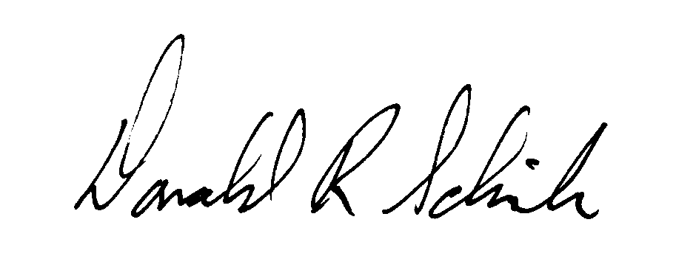

Donald R. Schreiber
Department of Chemistry
Western Michigan University
Kalamazoo, MI 49008-5413

